Creating an IntelliJ Project that can use AspectJ

**Note:** These instructions will **ONLY** work with IntelliJ Ultimate Edition

### Add the AspectJ Dependencies into Maven Project

1. Open up a new IntelliJ Maven Project
2. Click Enable Auto-Import
3. Add the following dependencies into your pom.xml file

<dependency>

<groupId>org.aspectj</groupId>

<artifactId>aspectjrt</artifactId>

<version>1.8.9</version>

</dependency>

<dependency>

<groupId>org.aspectj</groupId>

<artifactId>aspectjweaver</artifactId>

<version>1.8.9</version>

</dependency>

1. Add the following plugins into your pom.xml file. These plugins will allow maven to use the ajc compiler

*<build>*

*<plugins>*

*<plugin>*

*<groupId>org.codehaus.mojo</groupId>*

*<artifactId>aspectj-maven-plugin</artifactId>*

*<version>1.11</version>*

*</plugin>*

*<plugin>*

*<groupId>org.apache.maven.plugins</groupId>*

*<artifactId>maven-compiler-plugin</artifactId>*

*</plugin>*

*</plugins>*

*</build>*

**Note:**If IntelliJ can’t find the aspectj-maven-plugin, copy and paste the maven dependency from [this repository.](https://mvnrepository.com/artifact/org.codehaus.mojo/aspectj-maven-plugin) Replace the <dependency> tags with <plugin> tags

### Add the AspectJ ajc compiler to IntelliJ

1. In the Settings/Preferences menu dialogue, select **Build,Execution, Deployment | Compiler | Java Compiler**
2. From the **Use Compiler** list, select **Ajc**
3. Specify the path to the compiler in the **Path to aspectjtools.jar** field.
   1. **You want** the path to the **aspectjtools.jar** which is located in <AspectJ installation directory>\lib
4. If you need more help, refer to the IntelliJ guide below

<https://www.jetbrains.com/help/idea/using-the-aspectj-ajc-compiler.html>

Setting the ajc compiler in intelliJ should look like the screenshot below

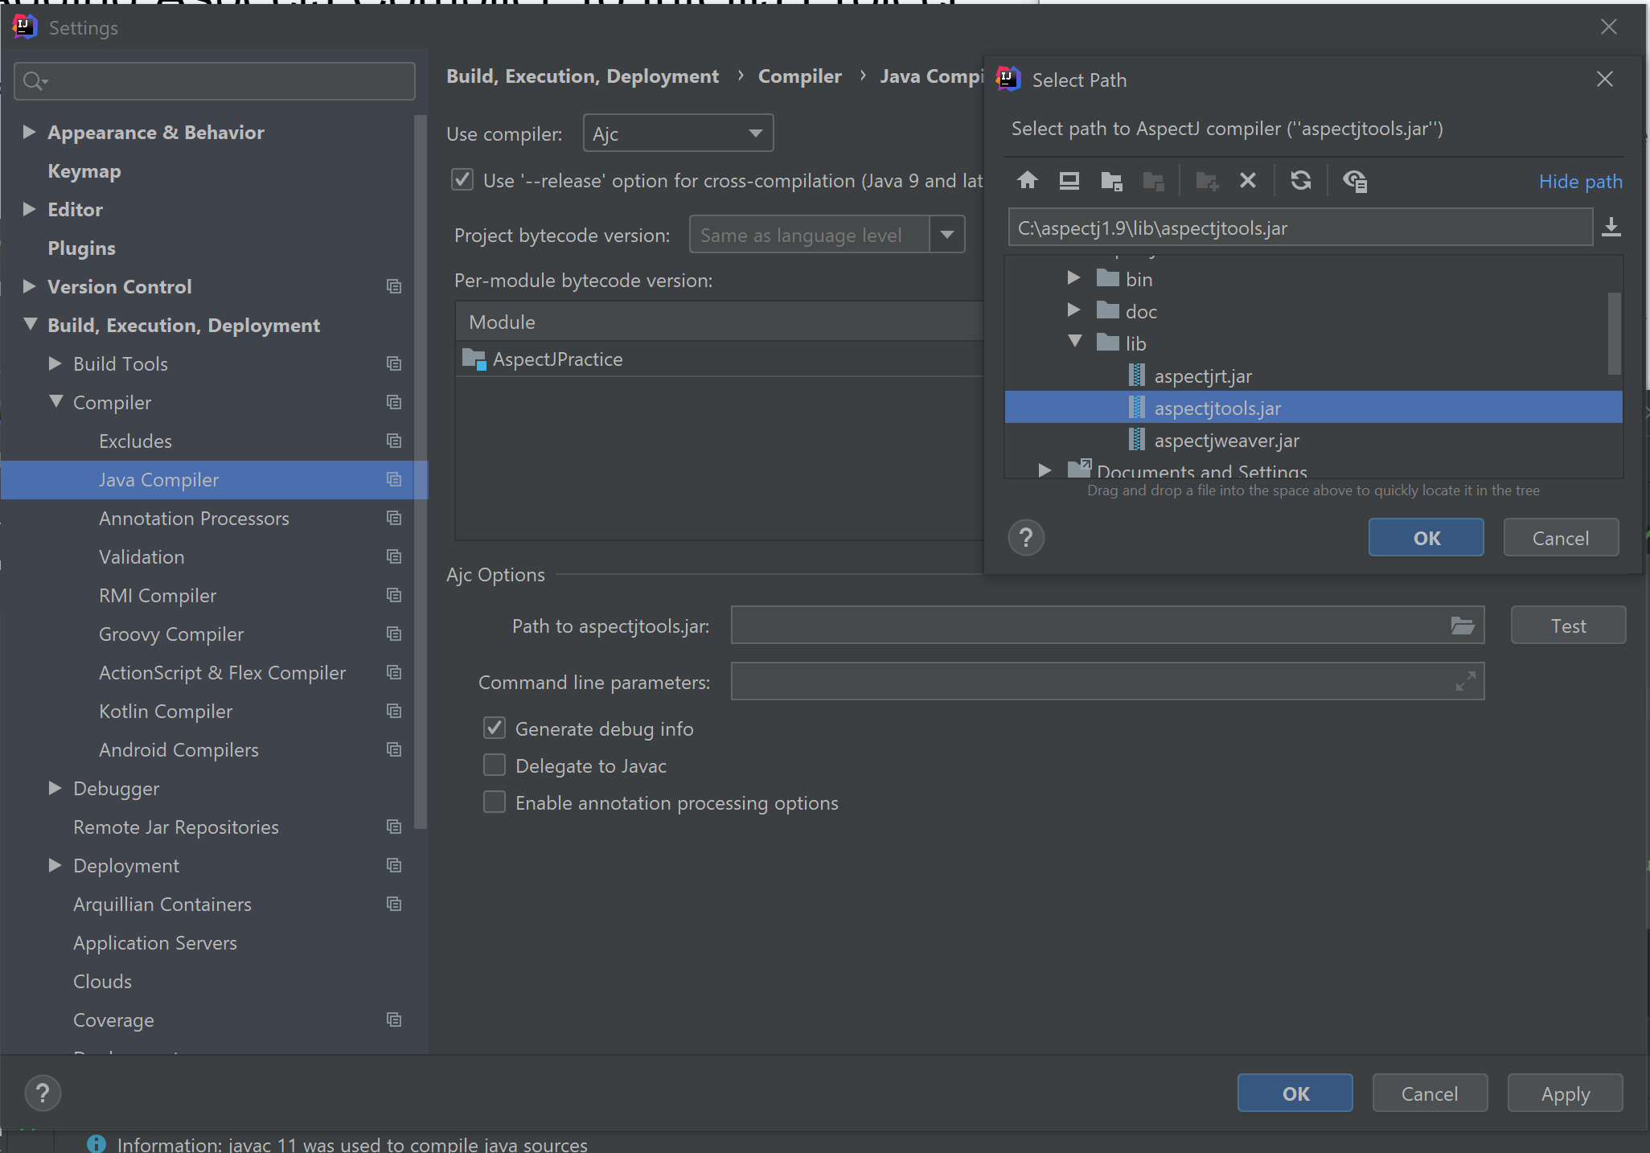

1. You can test your set up by downloading these files:<https://drive.google.com/file/d/1QSsP4cB-Swqu6rGbK-fKpIKSicC3qMkv/view?usp=sharing>
   1. Put the files into your project’s java folder
   2. Run the main method in the YourClass.java file
   3. When run, your output should like the screenshot below

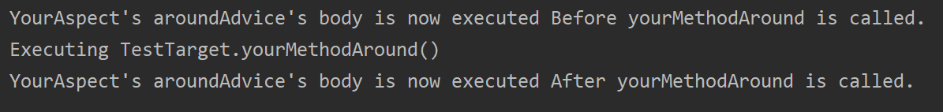

Note: if you did not get an output like the screenshot above, go to your Settings -> Build, Execution, Deployment -> Compiler -> Java Compiler. Double-check if Ajc is selected as the compiler instead of javac and that your Module target bytecode version is 1.8 or above.